Rugged Individualists Don’t Achieve as Quickly as Group Goal Setters,
Says Psychologist Who Teaches MasterMinding 101 Online Course

Salem, OR –  It’s a goal-achievement tradition that goes back as far as Benjamin Franklin and Henry Ford: convening a group of like-minded individuals and meeting regularly to support one another’s progress toward similar goals. Now Mary Robinson Reynolds has updated that practice for the Internet Age, with an online course called MasterMinding 101: 12 Sessions to a Rich Life ($79.00, www.MasterMinding101.com).  “So many people never achieve their dreams because they are trying to do it all by themselves,” says Reynolds, who combines her experience as a psychologist with a masters degree in counseling with years of study of classics like Napoleon Hill’s Think and Grow Rich. “When two or more minds come together, the result is greater than the sum of its parts. Having several people focus on how you can reach your goals is like lightning in a bottle – incredibly powerful stuff!”  Her program offers insights, anecdotes, exercises and complete instructions for creating and running a MasterMind group, including:  - how to formulate MasterMind requests that will be answered  - the principle of attraction that ensures that people find others who are vibrating at the same frequency  - why “over-effort” is counterproductive and what to do instead  - how to transform an ambiguous life goal into something with promise and power  - why disrupting your habits can create the future you really want  - ways to set energy in motion and get results easily and quickly | 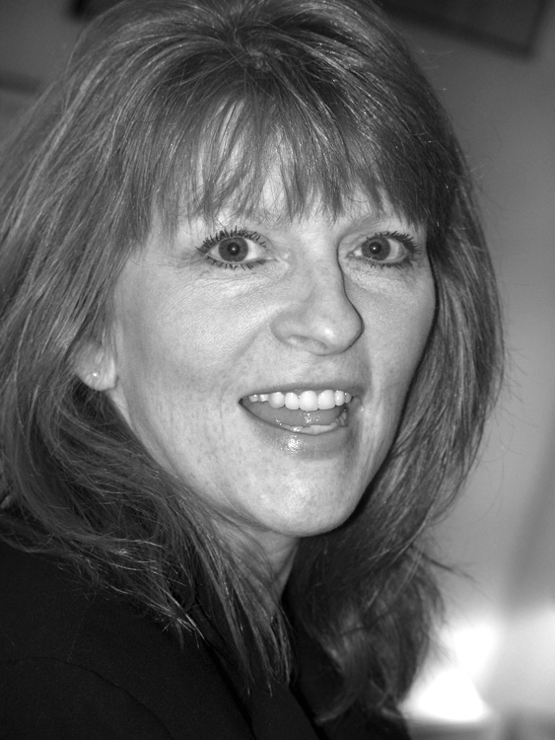  “With weekly meetings in person, you experience a ritual of showing up and learning how to hear your inner voice and urgings, while online meetings offer a way to deal with instant need and fear,” Reynolds says. “My program has a place for both.”  MasterMinding 101: 12 Sessions to a Rich Life by Mary Robinson Reynolds is available for $79 through the web site:  www.MasterMinding101.com  The tuition includes unlimited access to the MasterMinding lessons and private group discussion board.  Mary Robinson Reynolds is available for interviews nationwide, by calling 1-800-639-8191 – for emergency call Cell (603)997-1908 - or by emailing Mary@MarySpeaks.com  FOR SHOW PREP KIT: www.MarySpeaks.com

ATTENTION PRODUCERS: Mary's greatest expertise IS working with callers.

CREDENTIALS: Veteran talk show guest Mary Robinson Reynolds, M.S., The MasterMinding Maven™, has over 30 years experience as an educational psychologist, counselor, coach, master trainer, and is the author of five books, online courses and audio programs including Stay Married™ - Make More Love & Less Conflict and MasterMinding 101: 12 Sessions to a Rich Life. Mary brings an unconventional perspective to healing today's marriages: What you think about, comes about!

FOR MORE INFORMATION: To see Mary doing TV Interviews and working with callers, visit the Media Room at our Website: www.maryspeaks.com

AVAILABILITY: Nationwide by arrangement and via telephone

CONTACT Mary, 800-639-8191, Cell 603-997-1908, Email: Mary@MarySpeaks.com

