Straying Spouse? Affairs Can be Stopped and the Marriage Healed,
Says Psychologist With Unconventional Relationship Healing Strategies

Portsmouth, NH –  Not even a master’s degree in counseling could prevent Mary Robinson Reynolds from seeing her husband walk out the door and file for divorce.  She felt his heart leave the marriage and intuitively knew exactly when he consummated a long-standing attraction to another woman. To restore her marriage, Reynolds changed the way she was thinking about her relationship.  Despite being out of touch, and hostile to what he called “woo-woo” spiritual ideas, her husband responded to this shift in energy between them and returned home to recreate a loving commitment with Mary.  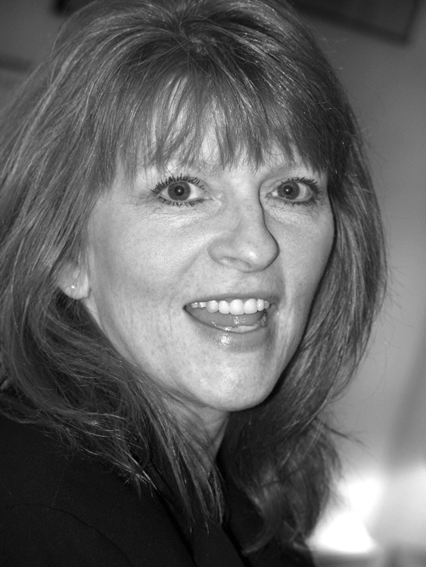  ● Infidelity is in the Majority!  Although some 50-60% of married men and 45-55% of married women engage in extramarital affairs at some point during their relationship, Mary Robinson Reynolds maintains that many of those marriages do not need to end.  At the same time, she claims that many marriages where infidelity has not yet occurred are ticking time bombs because one or both partners are engaging in adultery in their minds.  FOR SHOW PREP KIT: Mary@MarySpeaks.com | Mary Robinson Reynolds’ new Stay Married: Make More Love & Less Conflict Online Course & Audio Program (www.IWantToStayMarried.com, $79) helps men and women revitalize and restore a marriage that may appear to have ended. “But it’s not over unless you decide it’s over,” she states.  Her program offers unconventional spiritual insights and practical perspectives on healing a marriage damaged by infidelity, including:  - What makes emotional or mental infidelity every bit as dangerous for a marriage as physical betrayal.  - Why you’re not crazy for still loving your spouse and wanting to reconcile.  - Why and how just one partner can bring both back together again.  - What “spiritual alignment” means and how it can recreate that missing spark.  - Why getting your mate to change is irrelevant to reviving the vanished love vibes.  - How to apply – for better or worse – Einstein’s principle that “Your mind is the theater of coming attractions.”  Stay Married: Make More Love & Less Conflict - Online Course & Audio Program by Mary Robinson Reynolds is available for $79 through the web site:  www.IWantToStayMarried.com

ATTENTION PRODUCERS: Mary's greatest expertise IS working with callers.

CREDENTIALS: Veteran talk show guest Mary Robinson Reynolds, M.S., The MasterMinding Maven™, has over 30 years experiennce as an educational psychologist, counselor, coach, master trainer, and is the author of five books, online courses and audio programs including Stay Married™ - Make More Love & Less Conflict and MasterMinding 101: 12 Sessions to a Rich Life. Mary brings an unconventional perspective to healing today's marriages: What you think about, comes about!

FOR MORE INFORMATION: To see Mary doing TV Interviews and working with callers, visit the Media Room at our Website: www.maryspeaks.com

AVAILABILITY: Nationwide by arrangement and via telephone

CONTACT Mary, 800-639-8191, Cell (603)997-1908, Email: Mary@MarySpeaks.com

